Ex.No : 9 USE GHIDRA TO DISASSEMBLE AND ANALYSE THE MALWARE CODE
Date :

Project Objectives
- To provide a hands-on guide to disassembling and analyzing malware with Ghidra.
- To enable readers to recognize common malware functionalities, such as persistence mechanisms, anti-analysis techniques, and network communications.
- To equip users with the skills to interpret low-level assembly code and understand high-level behaviours.

GitHub Repository Components
A GitHub repository for this project could include:
- README.md
  - Overview: Brief description of Ghidra, its installation, and how it is used for malware analysis.
  - Requirements: List of requirements, including Ghidra, a VM setup, and any sample binaries (preferably benign samples or detailed steps to safely acquire controlled malware samples).
  - Project Outline: A breakdown of the tutorial steps, linking to various sections or files within the repository.
- Tutorial Steps (Markdown or Jupyter Notebooks) o Step-by-step instructions, broken down into digestible sections, such as:
▪ Environment Setup: Instructions on setting up a virtualized and isolated environment.
▪ Initial Analysis: How to load a binary into Ghidra, perform auto-analysis, and identify entry points.
▪ Function Analysis: Methods for identifying and analyzing critical functions, decompiling code, and using Ghidra’s cross-referencing features.
▪ String and Import Analysis: How to locate and interpret strings and imports related to malicious behavior.
▪ Advanced Techniques: Dynamic analysis, control flow graphs, custom scripting with Ghidra’s Python or Java capabilities, and obfuscation detection.

- Example Scripts (Python or Java) o Scripts to automate repetitive analysis tasks, such as:
▪ Extracting and listing all string references.
▪ Identifying network-related functions or common indicators of malware.
▪ Labeling functions and data segments based on known patterns (e.g., file system manipulation, registry edits).
  - Script Examples: Python or Java code snippets demonstrating API usage in Ghidra (using Ghidra’s Headless Analyzer, for example, for automation).
- Sample Data (Benign Binary or Hex Dump) o Due to safety and ethical concerns, include only safe, benign binaries or a hex dump example rather than live malware. This can allow users to learn and practice without the risk of executing malicious code. o Sample binaries designed to exhibit typical malware-like behaviors, such as:
▪ Executing system calls.
▪ Writing to files.
▪ Sending network data.
  - Alternatively, a dummy binary generator script that creates binaries with similar structures to malware but without harmful payloads.
- Documentation and Comments
  - Include explanations of the code within each script, detailing what each function does. o Inline comments in disassembly views, providing readers with insights into assembly commands, control flow structures, and the decompiled code.
- Report Template o A reporting template for documenting findings, which could be in Markdown or PDF format. The template should cover:
▪ Summary of Analysis: Brief description of the suspected malware.
▪ Function Analysis: Summary of the key functions, their purpose, and the findings.
▪ Behavioral Indicators: Summary of malware behaviors, such as persistence, file system manipulation, or network communications.
▪ Recommendations: Suggestions on further actions, such as containment, eradication, or further analysis.

Example Repository Structure plaintext ghidra-malware-analysis-project/
├── README.md
├── docs/
│ ├── Tutorial_Step1.md
│ ├── Tutorial_Step2.md
│ └── Tutorial_StepN.md
├── scripts/
│ ├── extract_strings.py
│ ├── network_analysis.py
│ └── label_functions.py
├── samples/
│ ├── benign_sample1.bin
│ └── benign_sample2.hex
├── templates/
│ └── analysis_report_template.md
└── screenshots/
├── function_graph_example.png
└── decompiler_example.png

Project Development and Future Work
- Expand Scripts: Continue adding Ghidra scripts to automate complex analysis tasks.
- Community Contributions: Encourage community members to contribute additional benign samples, analysis scripts, and documentation improvements.
- Advanced Topics: Include guides for advanced techniques, such as unpacking obfuscated code, identifying encryption routines, and using the P-Code emulator for runtime analysis.

SCREENSHOTS :

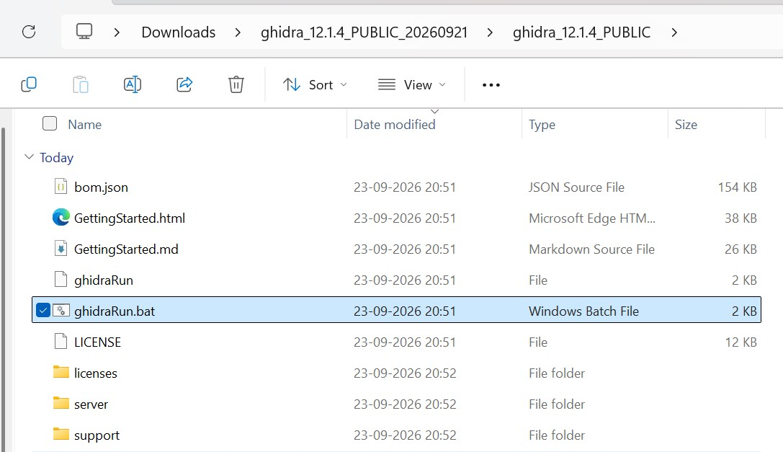

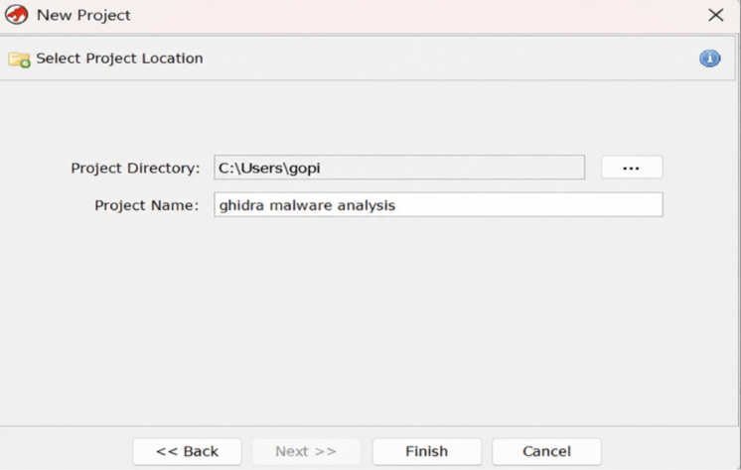

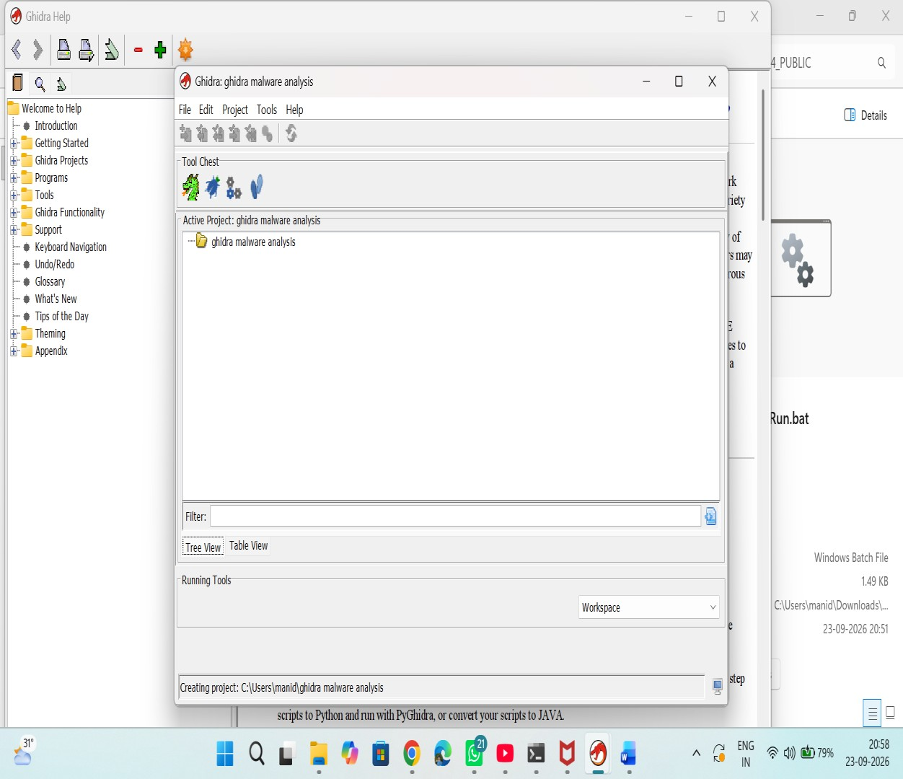
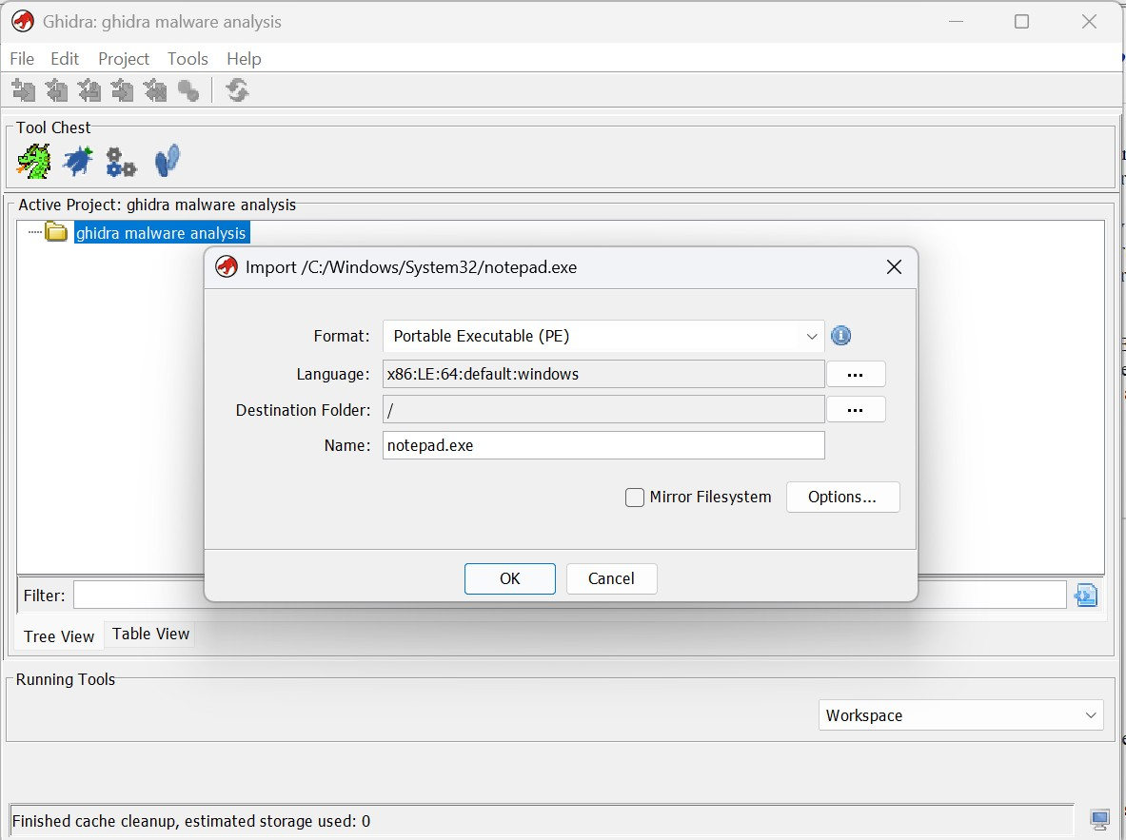

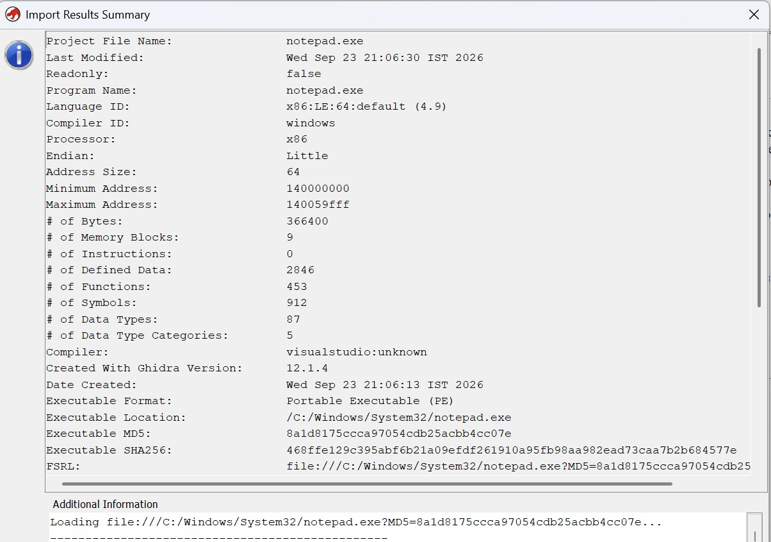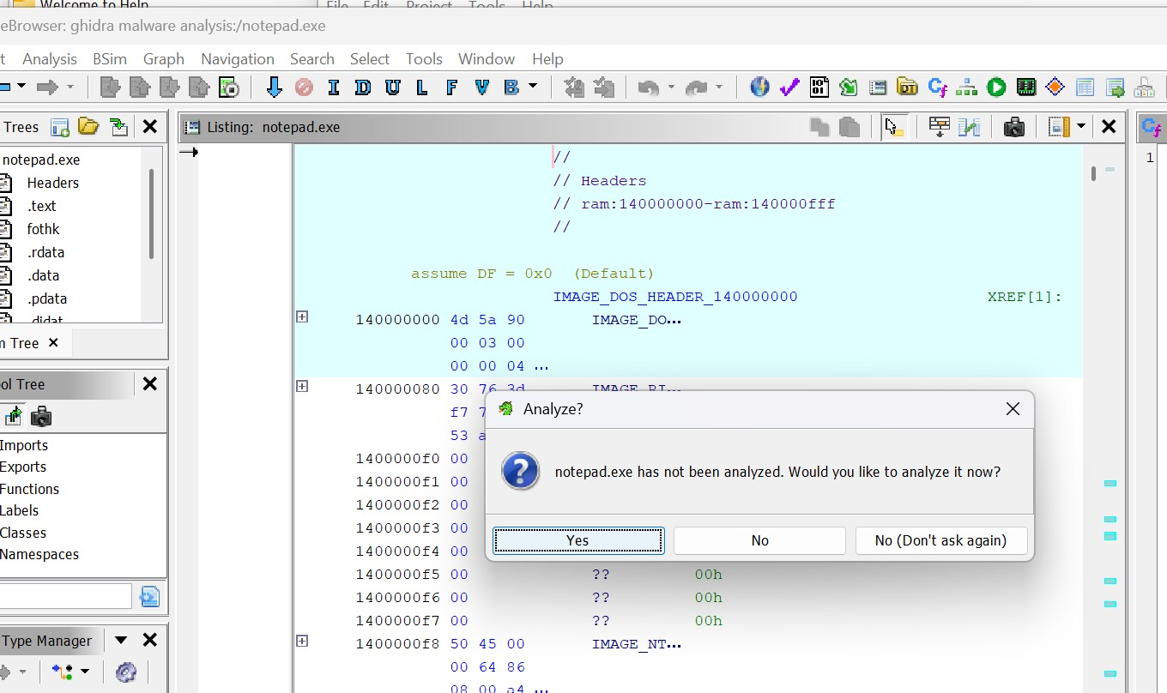

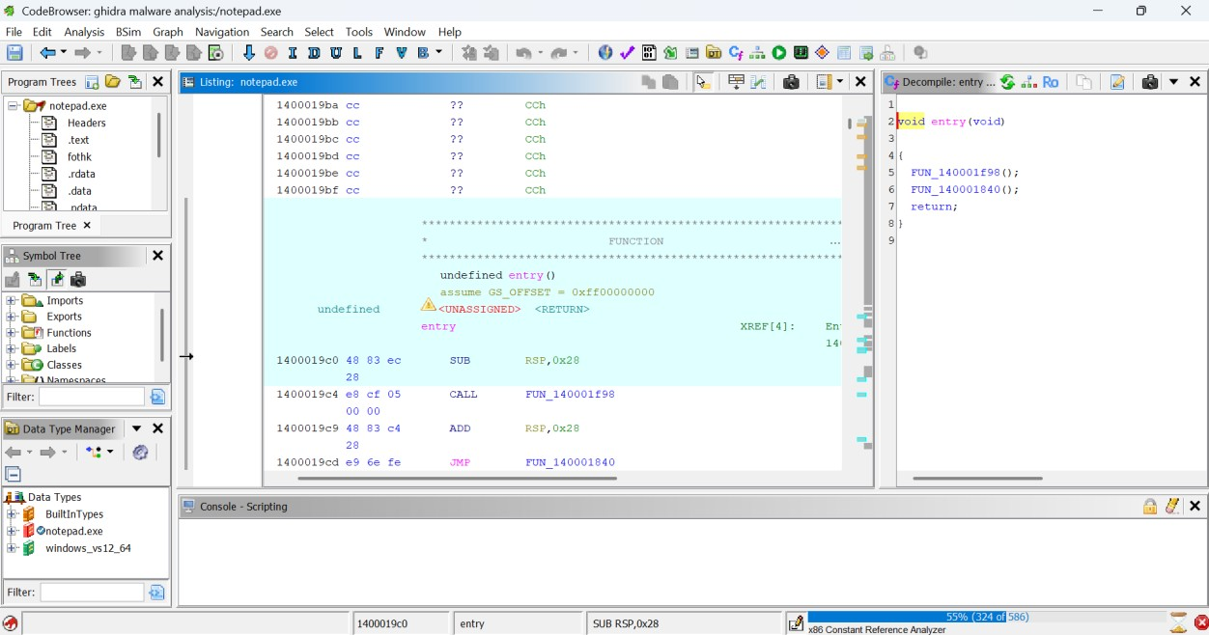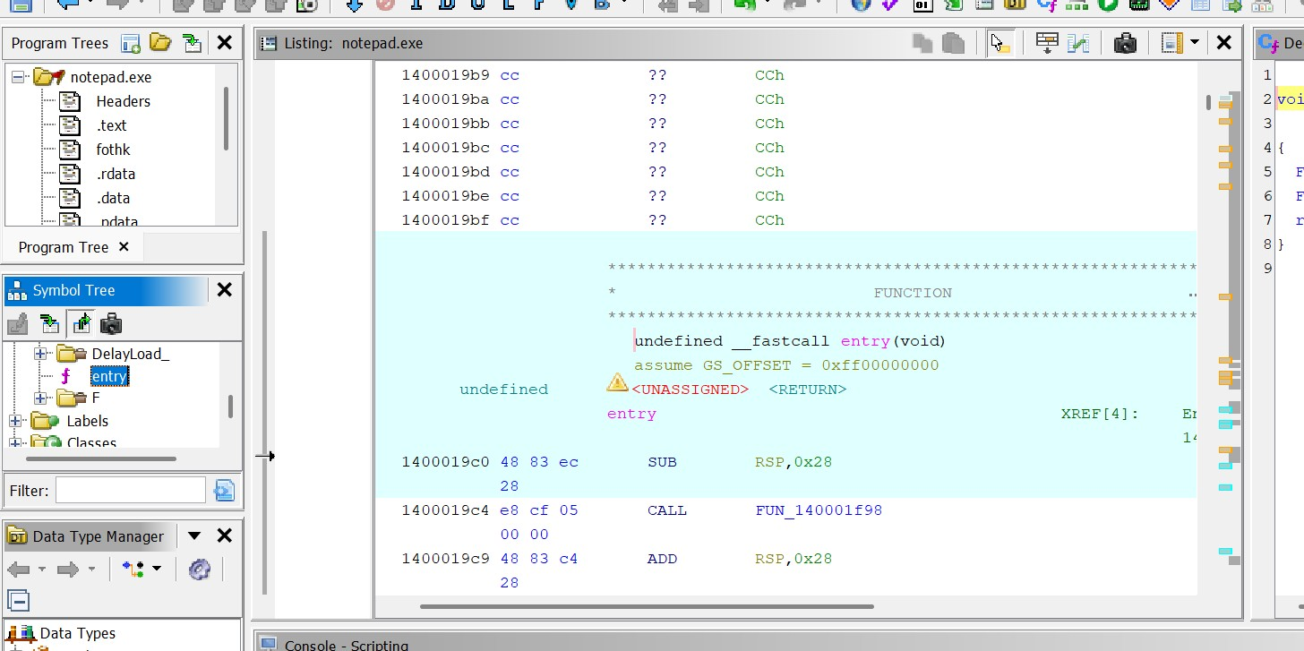

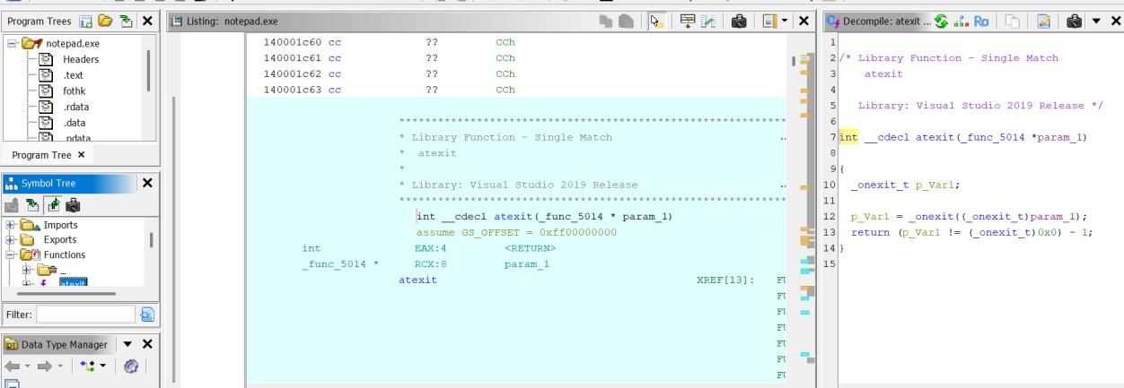
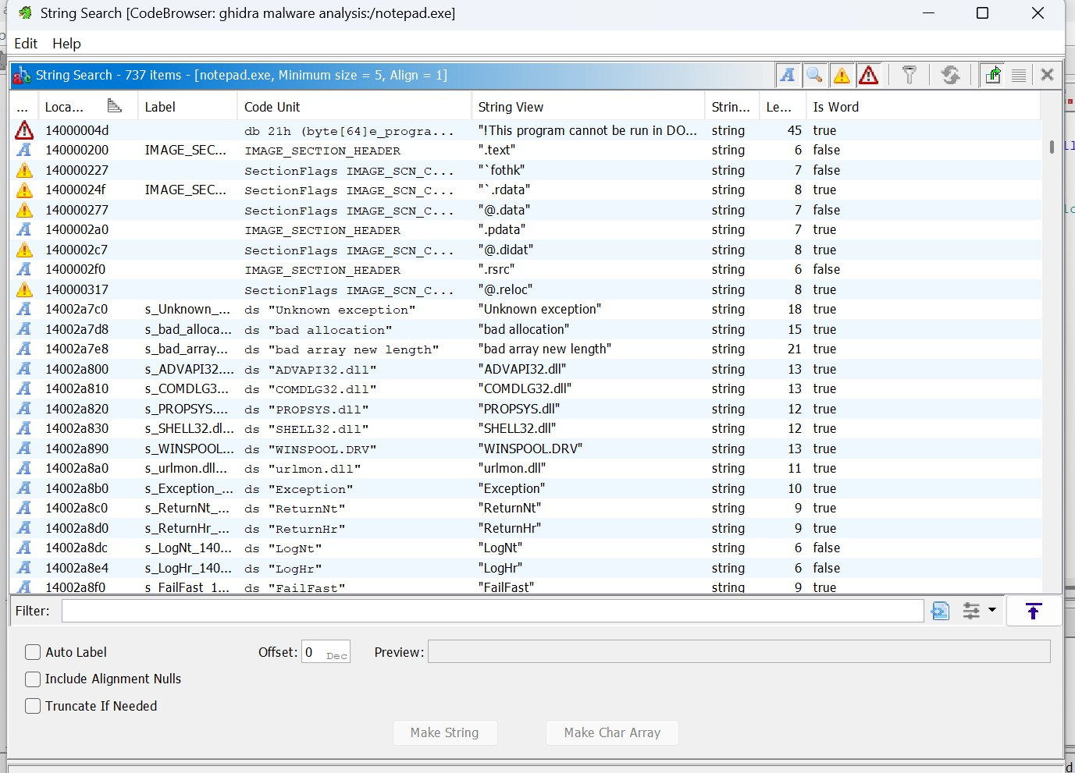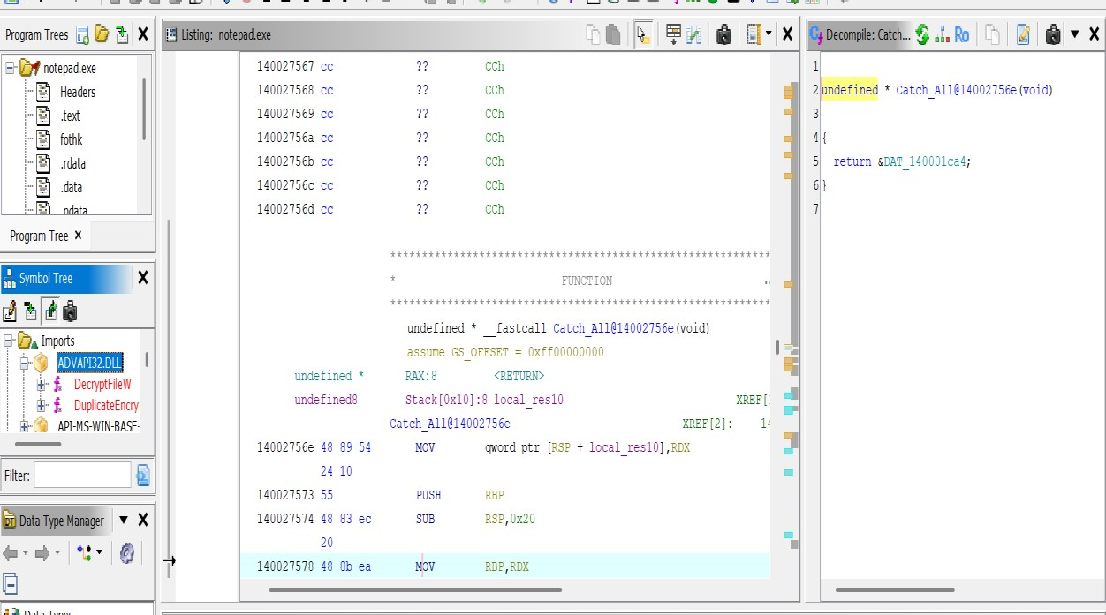

Rubrics:

Criteria & Marks Assigned | Mark Allotted | Mark Awarded
1. GitHub Activity & Submission Regularity | 3
2. Application of Forensic Tools & Practical Execution | 3
3. Documentation & Reporting | 2
4. Engagement, Problem-Solving & Team Collaboration | 2
Total | 10

Result:- The malware was successfully disassembled and analyzed using Ghidra.
The code structure, functions, and suspicious behaviors were identified successfully.

